Trent Giever

CS &141

Ch 3

4/12/2020

Problem # 2

Code:

/////////////////////////////////////////////////////////////////////////////////////////////////

/\*

Programmer: Trent Giever

Assignment Chapter: 3

Purpose: Demonstrate Car Class

Date modified: 4/12/2020

IDE/Tool used: NetBeans 8.2

\*/

package ch3.pkg1;

import static java.lang.System.out;

public class Ch31

{

public static void main(String[] args)

{

Car myCar = new Car(2020, "Test");

for(int i =0; i < 5; i++)

{

out.println("Current Speed is: " + myCar.getSpeed());

myCar.accelerate();

}

for(int i =0; i < 5; i++)

{

out.println("Current Speed is: " + myCar.getSpeed());

myCar.brake();

}

}

}

//////////////////////////////////////////////////////////////////////////////////////////////////

package ch3.pkg1;

public class Car

{

private int yearModel; //year of car

private String make; // model type

private int speed; // speed of the variable

public Car() //default constructor gives default value to variables

{

yearModel =0;

make ="";

speed =0;

}

public Car(int year, String m)//overloaded constructor assigns the users value

{

yearModel = year;

make = m;

speed = 0;

}

public int getYearModel() // returns the model year

{

return yearModel;

}

public void setYearModel(int year) //assigns the model year

{

yearModel = year;

}

public String getMake() // returns the make/model

{

return make;

}

public void setMake(String make) // sets the make/model

{

this.make = make;

}

public int getSpeed() //returns the cars speed

{

return speed;

}

public void accelerate() //increases speed by 5

{

speed +=5;

}

public void brake() //decreases speed by 5

{

speed -=5;

}

}

Snip:

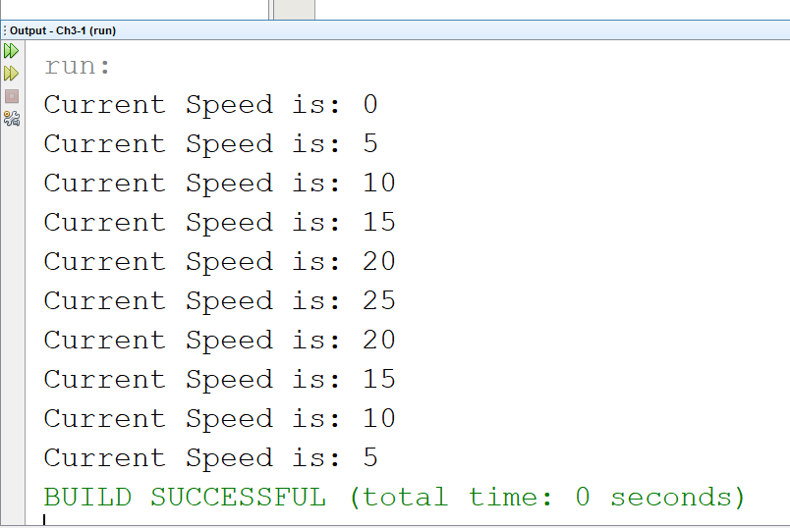

Program # 4

Code:

//////////////////////////////////////////////////////

/\*

Programmer: Trent Giever

Assignment Chapter: 3

Purpose: Temperature

Date modified: 4/12/2020

IDE/Tool used: NetBeans 8.2

\*/

package ch3.pkg2;

import static java.lang.System.out;

import java.util.Scanner;

public class Ch32

{

public static void main(String[] args)

{

Scanner in = new Scanner(System.in);

out.print("Enter a F temp: ");

Double t = in.nextDouble();

Temperature myTemp = new Temperature(t);

out.println("F: " + myTemp.getFahrenheit());

out.println("Celsius: " + myTemp.getCelsius());

out.println("Kelvin: " + myTemp.getKelvin());

}

}

/////////////////////////////////////////////////////

package ch3.pkg2;

public class Temperature

{

private double ftemp; //temp variable

public Temperature() //defualt constructor

{

ftemp = 0;

}

public Temperature(double temp) //overloaded constructor

{

ftemp = temp;

}

public void setFahrenheit(double f) //set F value

{

ftemp =f;

}

public double getFahrenheit()// return F value

{

return ftemp;

}

public double getCelsius() //convert to C

{

return ((5/9) \* (ftemp - 32));

}

public double getKelvin() //convert to K

{

return (((5/9)\* (ftemp -32)) + 273);

}

}

Snip:

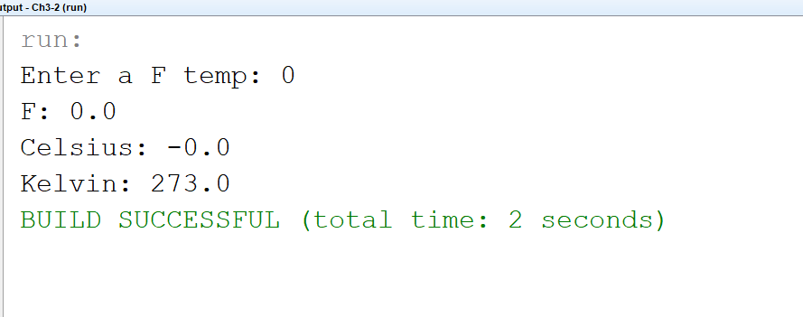

Program # 9

Code:

////////////////////////////////////////////////////////////////////////////

/\*

Programmer: Trent Giever

Assignment Chapter: 3

Purpose: Circle

Date modified: 4/12/2020

IDE/Tool used: NetBeans 8.2

\*/

package ch.pkg3;

import static java.lang.System.out;

import java.util.Scanner;

public class Ch33

{

public static void main(String[] args)

{

Scanner in = new Scanner(System.in);

out.print("Enter a radius: ");

double r = in.nextDouble();

Circle myCircle = new Circle(r);

out.println("Area: " + myCircle.getArea());

out.println("Diameter: " + myCircle.getDiameter());

out.println("Circumference: " + myCircle.getCircumference());

}

}

/////////////////////////////////////////////////////////////////////////////////

package ch.pkg3;

public class Circle

{

private final double PI = 3.14159; // final PI value

private double radius; // radius variable

public Circle() //default constructor

{

radius =0; //sets to 0

}

public Circle(double r) //overloaded constructor

{

radius = r; //sets radius

}

public void setRadius(double r) //set radius

{

radius =r;

}

public double getRadius() //return radius

{

return radius;

}

public double getArea() //returns area

{

return (PI \* radius \* radius);

}

public double getDiameter() //return diameter

{

return (radius \* 2);

}

public double getCircumference() //return circumference

{

return (2 \* PI \* radius);

}

}

Snip:

